MODULE 3

SECTION 2.2

1. Update the JavaBank.java application to implement a new light blue company color that is to be used across all of the graphical user interfaces in the Java application. The values to be used are Red: 173, Green 216 and Blue 230.

CODE:

**import javax.swing.*;**

**import java.awt.*;**

**public class JavaBank {**

**public static void main(String[] args) {**

**JFrame frame = new JFrame("JavaBank");**

**frame.setDefaultCloseOperation(JFrame.EXIT_ON_CLOSE);**

**frame.setSize(400, 300);**

**Color lightBlue = new Color(173, 216, 230);**

**JPanel panel = new JPanel();**

**panel.setBackground(lightBlue);**

**JButton button = new JButton("Submit");**

**button.setBackground(lightBlue);**

**button.setOpaque(true);**

**button.setBorderPainted(false);**

**JLabel label = new JLabel("Welcome to JavaBank");**

**label.setForeground(lightBlue);**

**JTextField textField = new JTextField(15);**

**textField.setBackground(lightBlue);**

**panel.add(label);**

**panel.add(textField);**

**panel.add(button);**

**frame.add(panel);**

**frame.setVisible(true);**

**}**

**}**

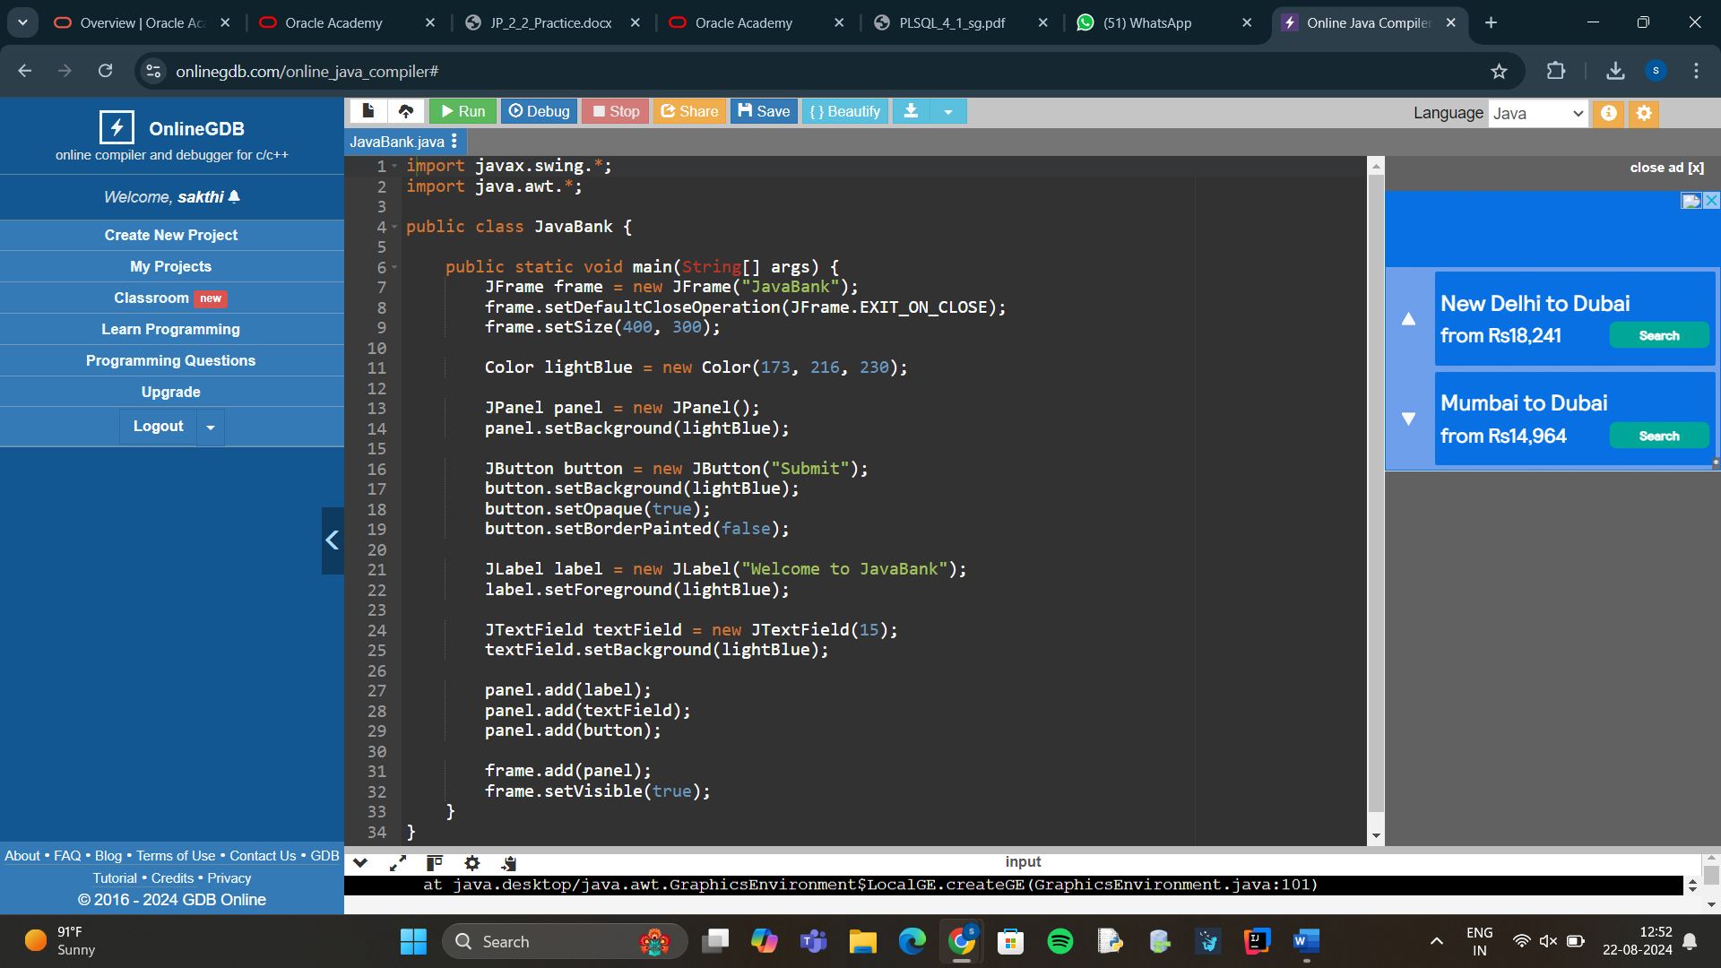

1. Create the following interface in the bike project that sets the name of the bike company as an unchangeable value. It also defines the methods that must be implemented by any class that uses the interface.

CODE:

package bikeproject;

public interface BikeParts {

String MAKE = "Oracle Bikes";

String getHandleBars();

void setHandleBars(String newValue);

String getTyres();

void setTyres(String newValue);

String getSeatType();

void setSeatType(String newValue);

}

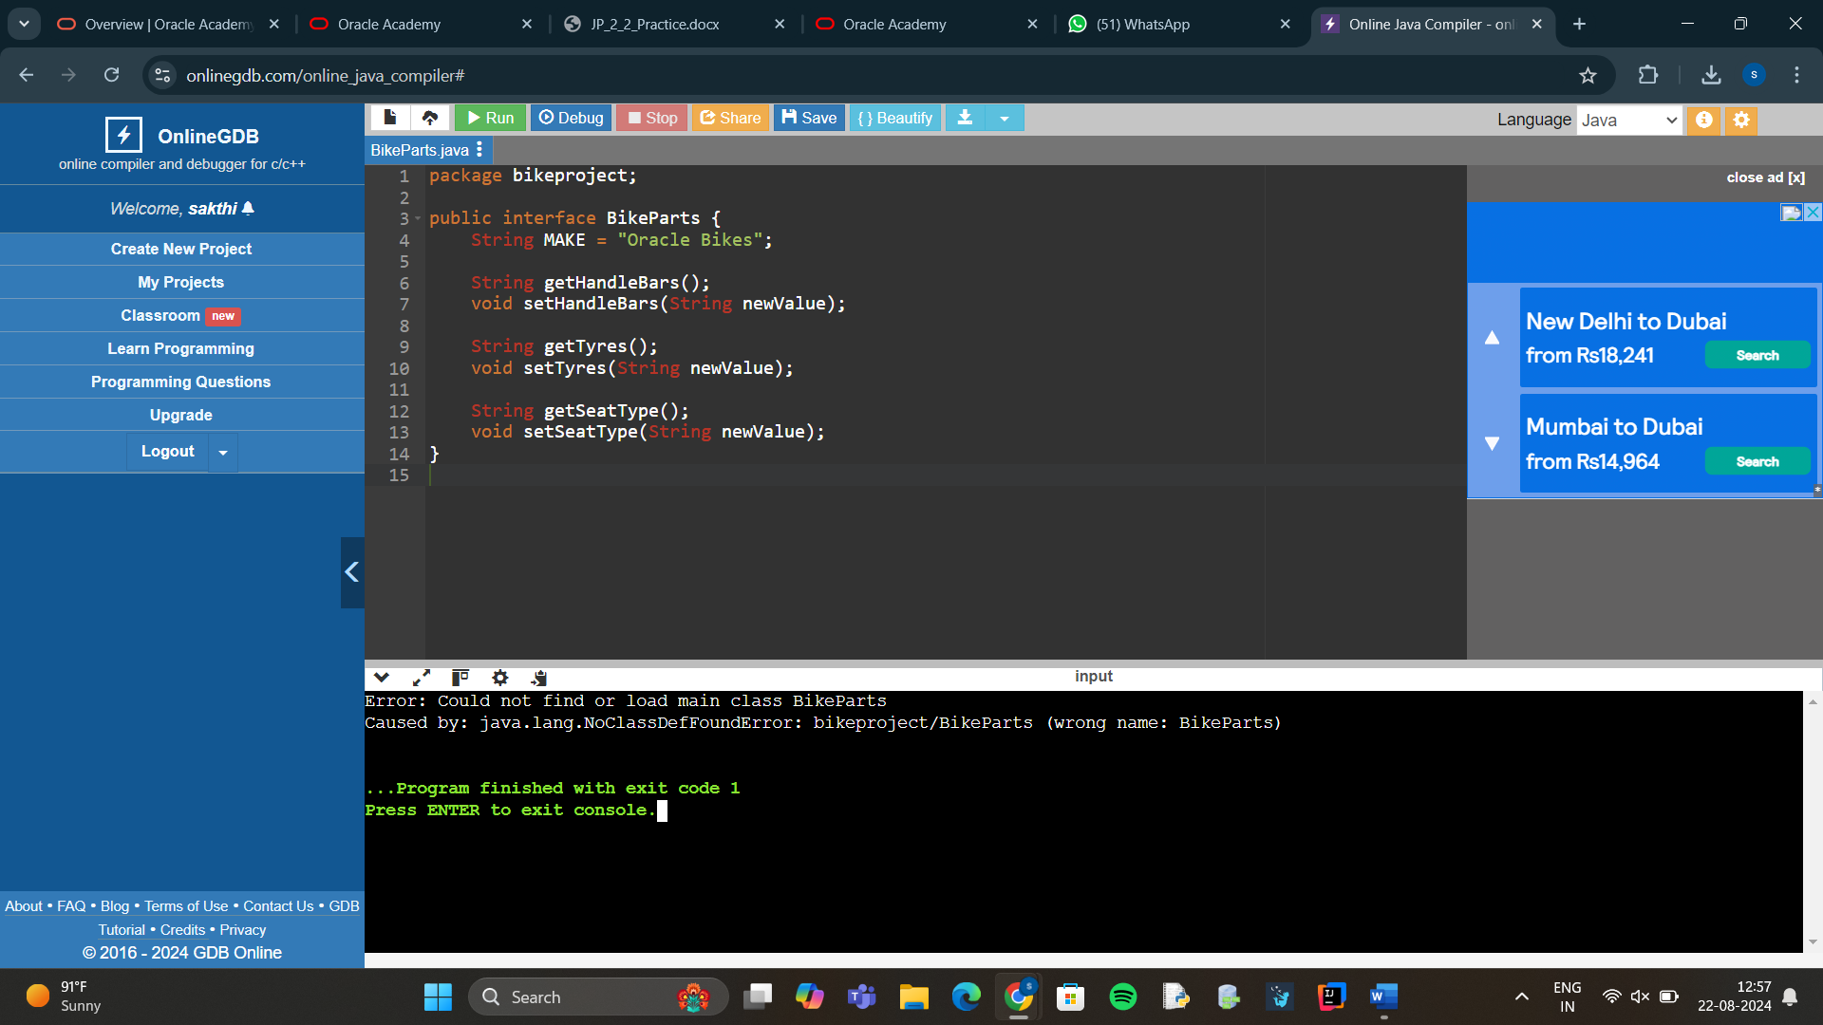

1. Create an interface named MountainParts that has a constant named TERRAIN that will store the String value “off_road”. The interface will define two methods that accept a String argument name newValue and two that will return the current value of an instance field. The methods are to be named: getSuspension, setSuspension, getType , setType.

**CODE:**

public interface MountainParts {

String TERRAIN = "off_road";

String getSuspension();

void setSuspension(String newValue);

String getType();

void setType(String newValue);

}

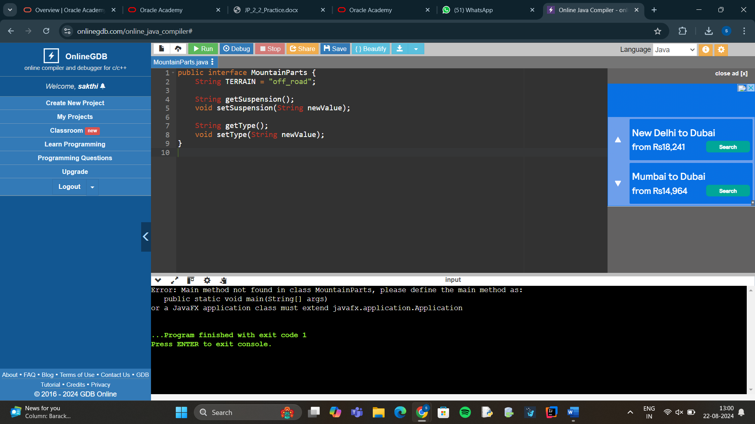

**4.**

**public interface RoadParts {**

**// Constant**

**String terrain = "track_racing";**

**// Methods**

**String getTyreWidth();**

**void setTyreWidth(String newValue);**

**String getPostHeight();**

**void setPostHeight(String newValue);**

**}**

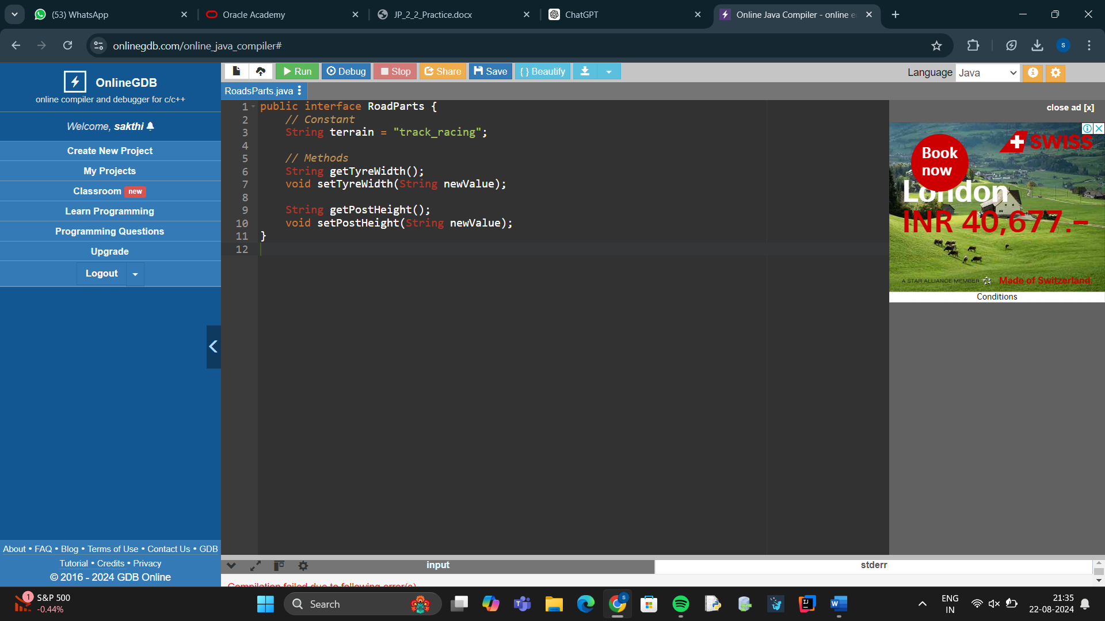

**5.**

**public interface BikeParts {**

**String type = "generic";**

**String getTyreWidth();**

**void setTyreWidth(String newValue);**

**String getPostHeight();**

**void setPostHeight(String newValue);**

**}**

**public class Bike implements BikeParts {**

**private String tyreWidth;**

**private String postHeight;**

**public Bike(String tyreWidth, String postHeight) {**

**this.tyreWidth = tyreWidth;**

**this.postHeight = postHeight;**

**}**

**@Override**

**public String getTyreWidth() {**

**return tyreWidth;**

**}**

**@Override**

**public void setTyreWidth(String newValue) {**

**this.tyreWidth = newValue;**

**}**

**@Override**

**public String getPostHeight() {**

**return postHeight;**

**}**

**@Override**

**public void setPostHeight(String newValue) {**

**this.postHeight = newValue;**

**}**

**@Override**

**public String toString() {**

**return "Bike [Tyre Width = " + tyreWidth + ", Post Height = " + postHeight + "]";**

**}**

**}**

**public class Main {**

**public static void main(String[] args) {**

**Bike myBike = new Bike("2.0 inches", "35 cm");**

**System.out.println("Tyre Width: " + myBike.getTyreWidth());**

**System.out.println("Post Height: " + myBike.getPostHeight());**

**myBike.setTyreWidth("2.2 inches");**

**myBike.setPostHeight("40 cm");**

**System.out.println("Updated Bike: " + myBike);**

**}**

**}**

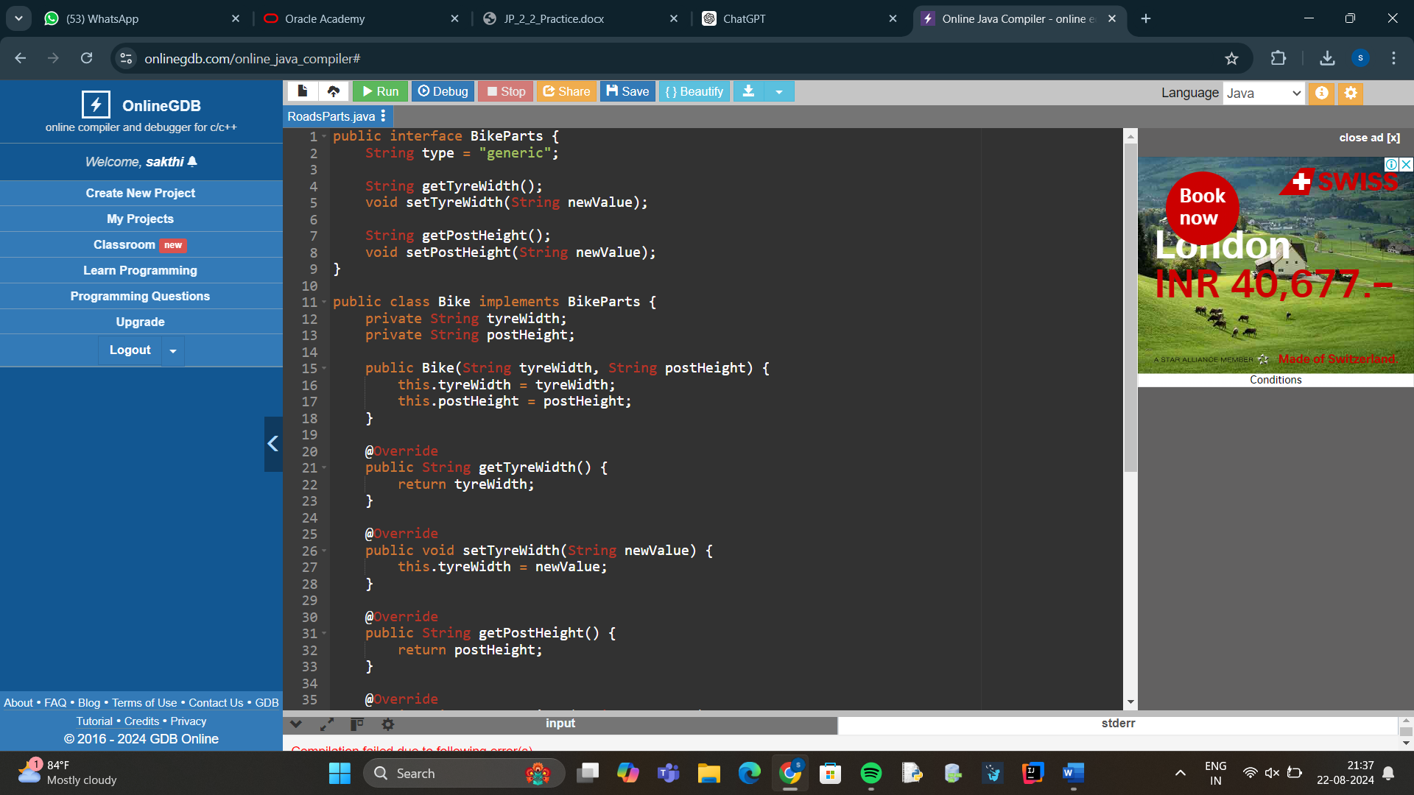

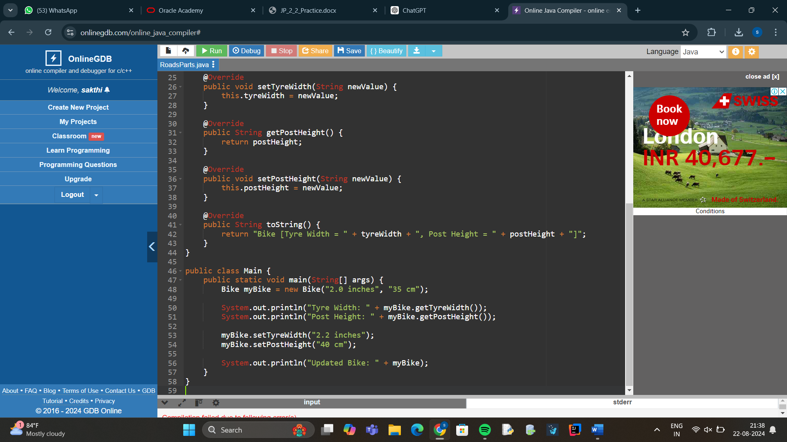

**6.**

**public interface MountainParts {**

**String terrain = "off_road";**

**String getSuspensionType();**

**void setSuspensionType(String newValue);**

**String getTireTread();**

**void setTireTread(String newValue);**

**}**

**public class MountainBike implements MountainParts {**

**private String suspensionType;**

**private String tireTread;**

**public MountainBike(String suspensionType, String tireTread) {**

**this.suspensionType = suspensionType;**

**this.tireTread = tireTread;**

**}**

**@Override**

**public String getSuspensionType() {**

**return suspensionType;**

**}**

**@Override**

**public void setSuspensionType(String newValue) {**

**this.suspensionType = newValue;**

**}**

**@Override**

**public String getTireTread() {**

**return tireTread;**

**}**

**@Override**

**public void setTireTread(String newValue) {**

**this.tireTread = newValue;**

**}**

**@Override**

**public String toString() {**

**return "MountainBike [Suspension Type = " + suspensionType + ", Tire Tread = " + tireTread + "]";**

**}**

**}**

**public class Main {**

**public static void main(String[] args) {**

**MountainBike myMountainBike = new MountainBike("Full Suspension", "Knobby");**

**System.out.println("Suspension Type: " + myMountainBike.getSuspensionType());**

**System.out.println("Tire Tread: " + myMountainBike.getTireTread());**

**myMountainBike.setSuspensionType("Hardtail");**

**myMountainBike.setTireTread("Slick");**

**System.out.println("Updated MountainBike: " + myMountainBike);**

**}**

**}**

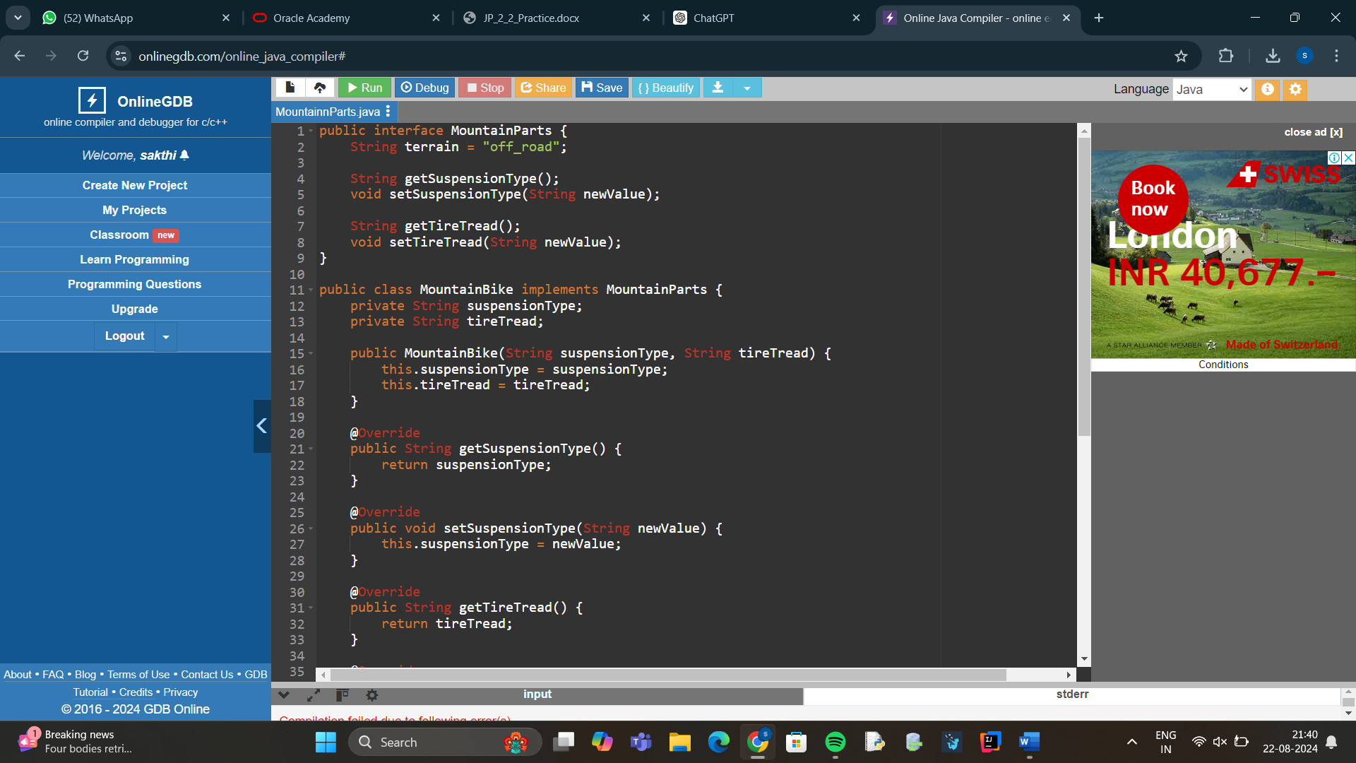

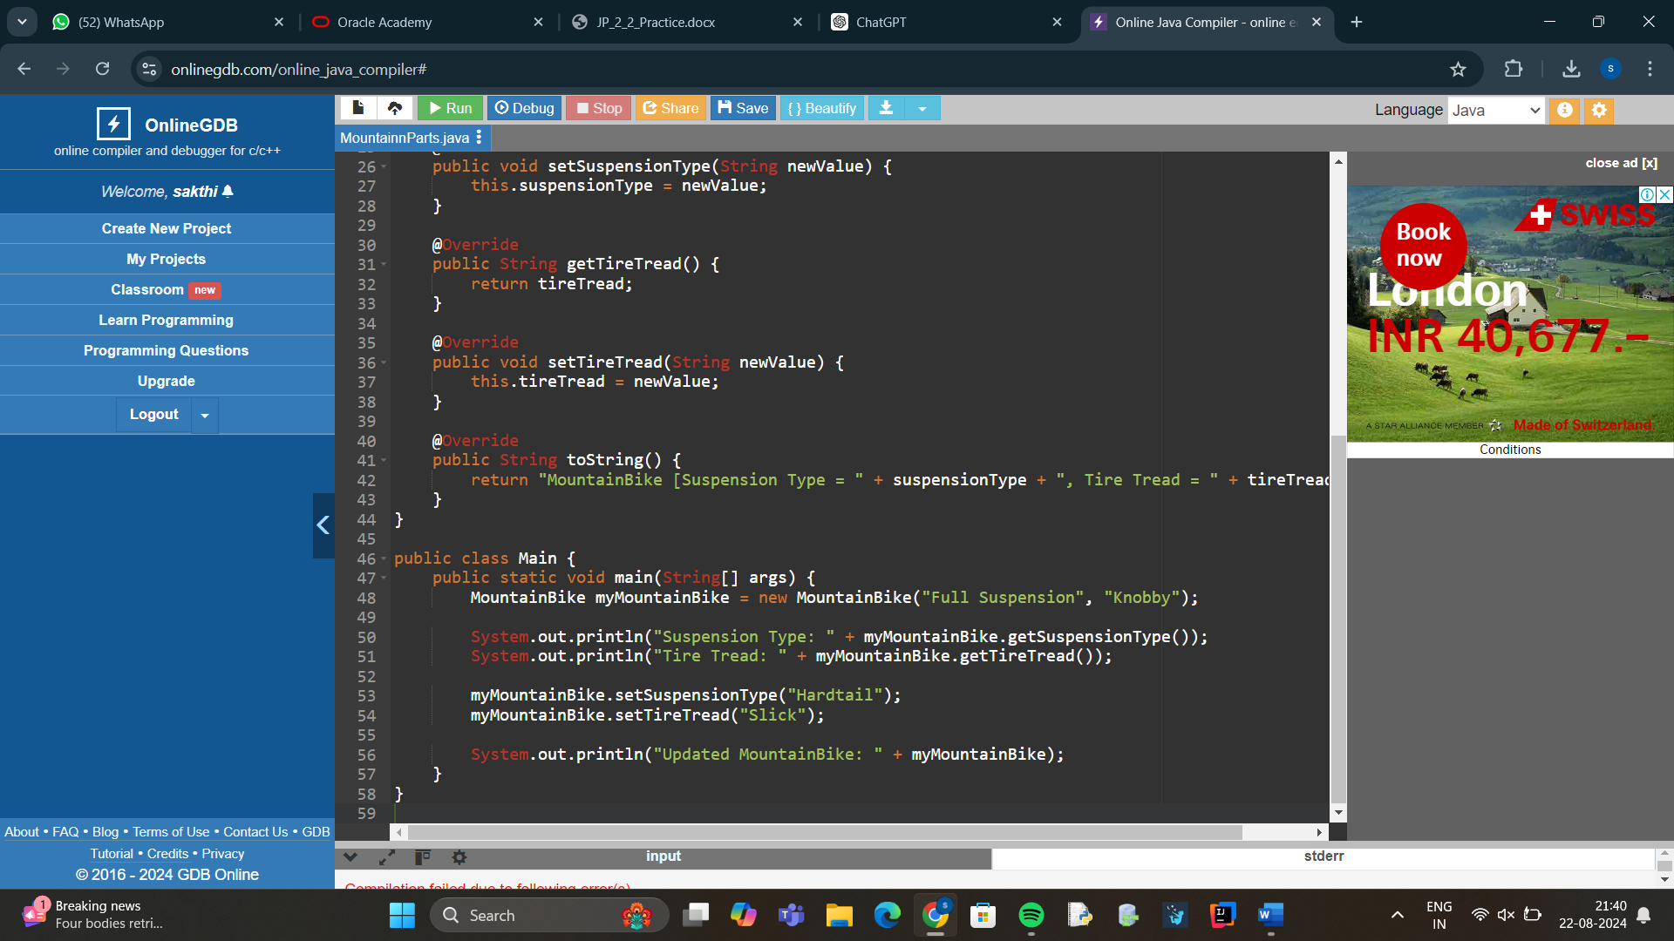

**7.**

**public interface RoadParts {**

**String terrain = "track_racing";**

**String getTyreWidth();**

**void setTyreWidth(String newValue);**

**String getPostHeight();**

**void setPostHeight(String newValue);**

**}**

**public class RoadBike implements RoadParts {**

**private String tyreWidth;**

**private String postHeight;**

**public RoadBike(String tyreWidth, String postHeight) {**

**this.tyreWidth = tyreWidth;**

**this.postHeight = postHeight;**

**}**

**@Override**

**public String getTyreWidth() {**

**return tyreWidth;**

**}**

**@Override**

**public void setTyreWidth(String newValue) {**

**this.tyreWidth = newValue;**

**}**

**@Override**

**public String getPostHeight() {**

**return postHeight;**

**}**

**@Override**

**public void setPostHeight(String newValue) {**

**this.postHeight = newValue;**

**}**

**@Override**

**public String toString() {**

**return "RoadBike [Tyre Width = " + tyreWidth + ", Post Height = " + postHeight + "]";**

**}**

**}**

**public class Main {**

**public static void main(String[] args) {**

**RoadBike myRoadBike = new RoadBike("1.5 inches", "30 cm");**

**System.out.println("Tyre Width: " + myRoadBike.getTyreWidth());**

**System.out.println("Post Height: " + myRoadBike.getPostHeight());**

**myRoadBike.setTyreWidth("1.7 inches");**

**myRoadBike.setPostHeight("32 cm");**

**System.out.println("Updated RoadBike: " + myRoadBike);**

**}**

**}**

